方式一：
贵方可以已本文形式上传举证附件，需每张单个用于投诉的图片截图与官网URL在一个页面显示，如下；
Example 1:
When you provide the evidence attachment, Please make sure the attachment should include the screen capture showing your copyrighted subject matter and the website URL to your copyrighted subject matter.

盗用官网图片
copyright image
官网具体图片地址:
Your copyright website URL：
http://www.alibabagroup.com/cn/about/overview
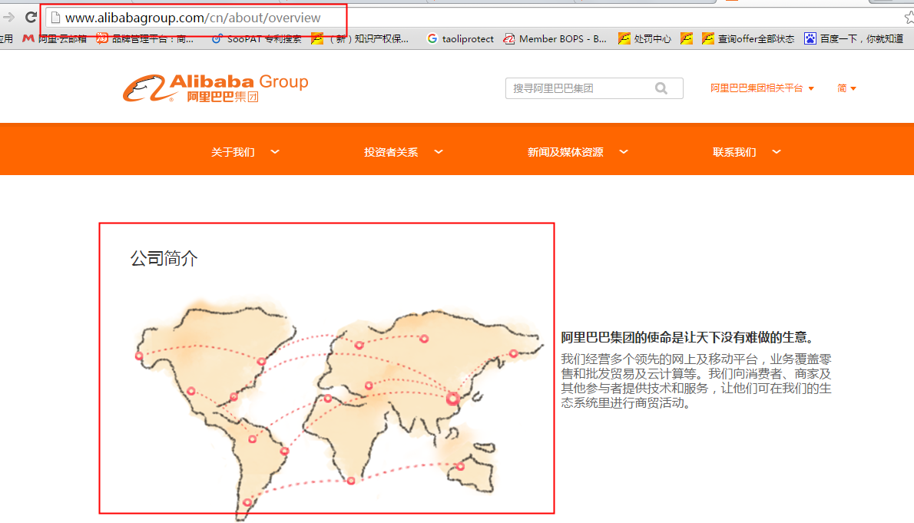
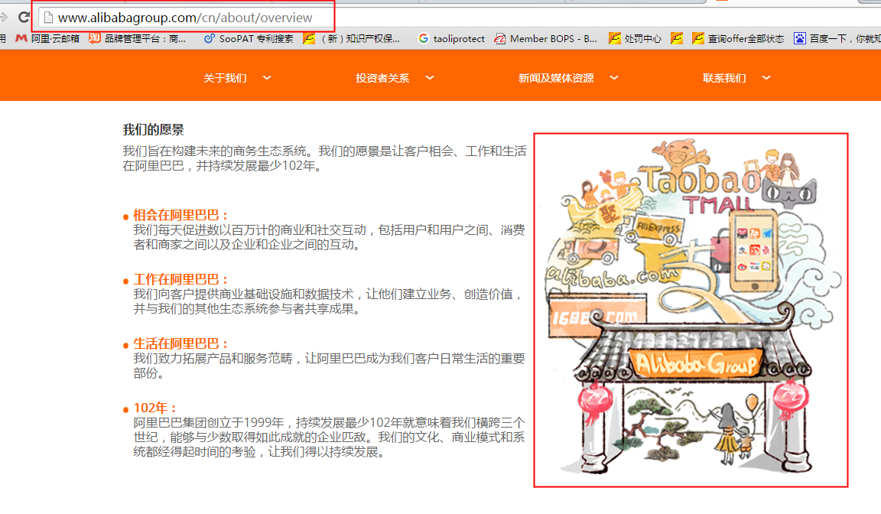

方式二：
贵方可在投诉理由处填写【官网具体产品的链接】，举证证明处上传【官网URL与用于投诉的图片一起展示的截图图片】，操作如下：
Example 2:
Please fill in your copyright website URL. And also provide us the screen capture showing your copyrighted subject matter and the website URL to your copyrighted subject matter.

